**Network Operations Center (NOC) UI**

Accessed at<http://localhost:8081> on the server machine, or on the network as <http://localIP:8081>

**Client Management**

1. **Adding a Client**

A client may be added through an add button at the bottom of the page. Only one input is required, and that is the IP. If no client name is defined, its name will default to its IP.

1. **Importing Clients**

Clients can be imported from an excel sheet, formatted with two columns – the left column titled “Name” and the right column named “IP” with each client’s respective information for each row. Clients with IPs that already exists in the database will not be copied over, and errors logs will be shown.

To import clients, the import button is located at the top left utility bar, expanded by a gear icon. Select the excel sheet for import, and it will report the live progress.

1. **Exporting Clients**

All clients in the database may be exported in an excel .xlsx file via the export button located in the utility bar located at the top left of the UI. This may take some time depending on the number of clients, but a download will start automatically once the export operation is finished. The exported file can also be interpreted by the import function, providing easy migrations.

**Searching a Client**

Clients can be found via the search bar on the top left of the client table. They can also be filtered by the 4 buttons, showing only the online, offline, pending, or simply all the clients via the buttons on the top right of the client table.

**Client Status Notifications**

1. **Email Notifications**

Emails can be sent as soon as a client’s status changes from online to offline, or offline to online – *only if they are not pending*. If a client is in pending state and changes to online, then no email will be sent. Configurations for email can be set through the Config button in the utility bar located at the top left of the UI.

**Email Failsafe**

There is a failsafe implemented to prevent an onslaught of emails sent in error if for some reason some false positive triggers en masse and a huge number of emails are sent. If a set number of emails is trying to be sent within a set interval, all further emails will be blocked from sending until the server is restarted. Settings for the failsafe can be accessed through the UI in the utility bar located at the top left of the UI.

1. **Visual Alerts**

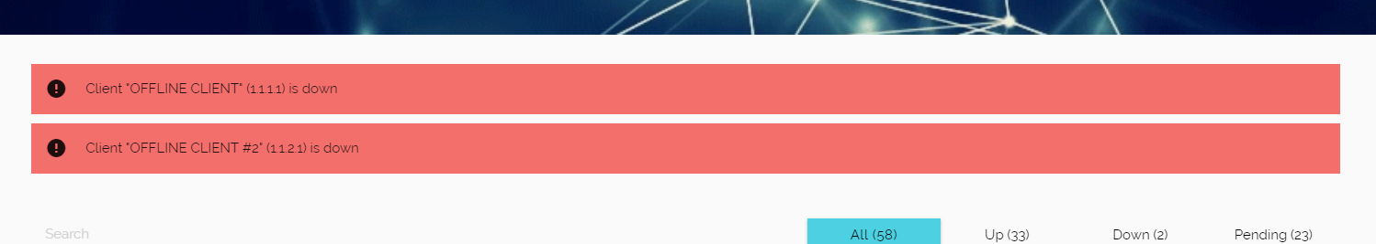

A visual alert can be shown for every client that is offline. It can be enabled/disabled by a Enable/Disable Alerts button located at the very bottom of the UI.

**Server Activity Log**

The Server Activity Log will show all notable changes happening on the backend, sent via websockets. The following information will be noted:

* Server bootup
* Import/Export operations
* Client status changes
* Email failures

**Searching a Client**

Manual Refreshes can be done via the Refresh button located in the utility bar at the top left of the UI.

**Configurations**

There are multiple configurations available through the configuration menu located in the utility bar at the top left of the UI. When changing configs, be absolutely sure of the values you’re setting since only limited validation is provided. Explanations are provided below.

**Email Settings** / * - Configure email settings/authorization. *This will not be shown if a password is required to enter the interface.*

**Email Failsafe** / Max Emails – The maximum number of emails allowed in an interval before disabling emails.

**Email Failsafe** / Interval (sec) - The interval in seconds during which the number of emails must be sent to trigger the failsafe.

**Ping Settings** / Number of Pings - The number of pings sent to each client to determine its status.

**Ping Settings** / Delay (min) - The delay between every round of pings in minutes.

**Ping Settings** / Number of Confirmations - The number of instances a status should be confirmed before official status update.

Ping Confirmations is a feature where it is possible to not immediately trigger notifications upon seeing that a client is offline. When the program sees a client as offline from online, it will not immediately change status and instead mark it as “potentially offline”. Once it sees it as “potentially offline” for a set number of times specified by the number of confirmations, only then will its status be changed.

**Kill Server**

In the case of a catastrophic situation, the server can be remotely killed via the Kill button located in the utility bar at the top left of the UI, completely disabling it.